Assignment 1:
Task 1:
Used libraries and their purpose:
Sklearn – python library for data machine learning. This library provides different tools that used to build, train and test machine learning models. In task one this library was used to import the iris data set, import the PCA feature that is used to reduce diminution as well the import the scaling feature that is used to scale the data.
Matplotlib –
Library that is used for data visualization, we can use this library to represent the data in charts and graphs. We can also use it to manipulate how the data is presented by giving labels, changing fonts, legends, styles etc.
Execution Results:
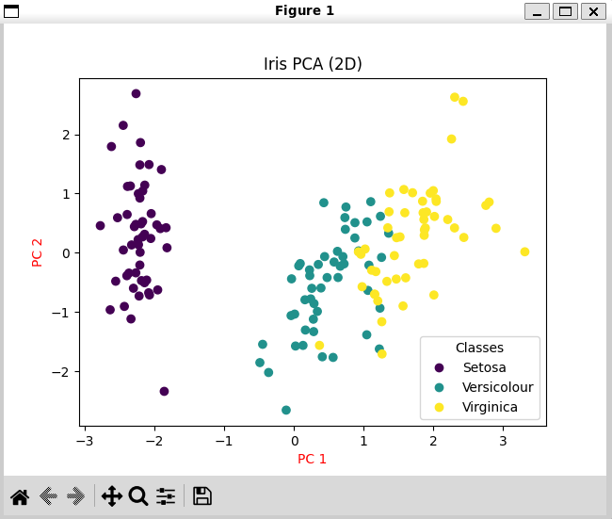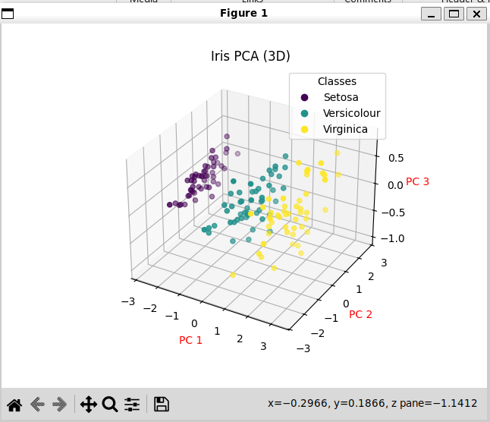
Interpret separation:
Both plots show that the Iris data set is characterized by one distinct class (the purple dots that represent the Setosa) and by two classes that are more related (turquoise and yellow dots that represent the Versicolour and Virginica, respectively). This separation happens because PCA identify the direction of the maximum variance that differentiates the classes based on their physical measurements. The gap between Setosa shows there is a characteristic difference between this class and the other two, and the overlap between the Versicolour and Virginica indicates that they have similar patterns.

Task 2:
Used libraries and their purpose:
Pandas –
This library is used for data manipulation and its purpose is to handle complicated tables and spreadsheets that otherwise would require more lines of code. This library provides a convenient way to handle those tables. It also can work along side other libraries as demonstrated in my code where it created the dataFrame for the housing data and later this structure is used matplotlib to create a box plot.
NumPy –
This library preforms the mathematical calculation of the data. It is very fast, can handle arrays, also provides support for vectorized operations which eliminates the need of loops. In addition, it has built in features for linear and statistical operations.
Execution Results:
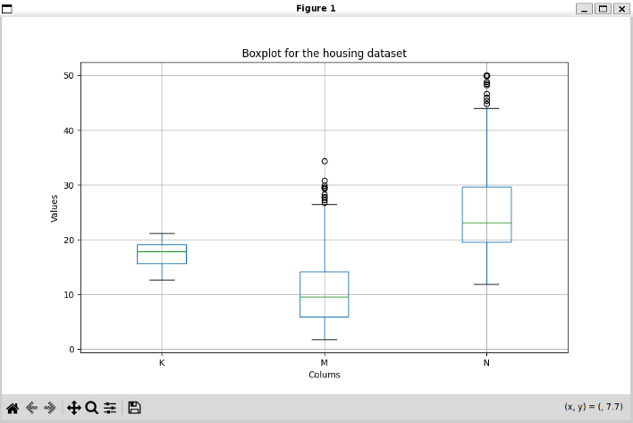
Interpretation:
Colum K which represents pupil- teacher Ratio by town shows a median value of 18.5. The Boxplot shows that most of data is in a smaller range compared to the other columns which is make sense since each columns measures a completely different type of data. The ratio in every town stays within the range of 13 and 21 and there is no extraordinary values.
As far Colum M which represents percentage of lower status of the population, The plot shows that while the average of lower status is from 4-16% , there are also specific town where this value is significantly higher (The dots at the top outside the box). Finally, column N which represents the Median value of Owner-Occupied homes, shows the highest values as expected since the value type here measure dollars and not percentages. And even though it divides by thousands it still expected to be higher numeric value then the rest. Therefore this is not a comparison between columns, each column is independent. There is a cluster of high value homes that is way above average.
Taks 3:
Used libraries and their purpose:
Matplotlib was used for task 3. This library was described in task 1.
Execution Results:
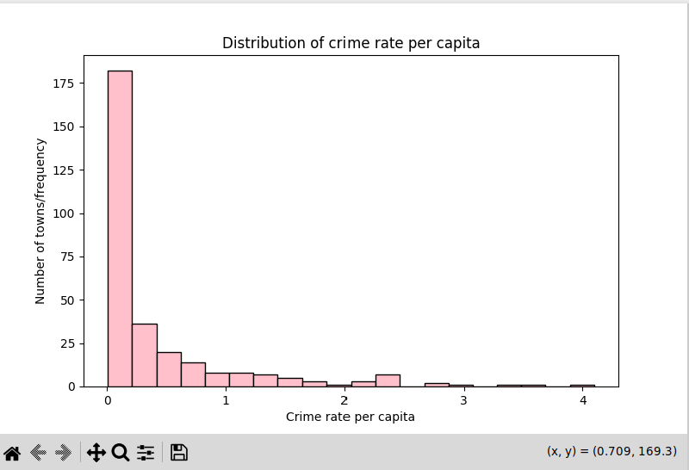
Interpretation:
The histogram shows frequency of the distribution, meaning from this we can read how many towns had lower amount of crime rate and in how many towns the crime rate was higher. From columns A in the housing data set we can see that most of the values are on the left closer to zero that means that most of the towns had a lower crime rate. The distribution pf the higher crimes rates is among fewer towns.

Testing the code Execution Results:
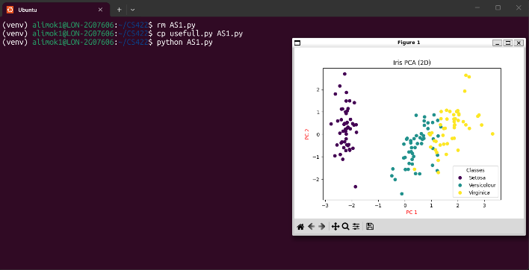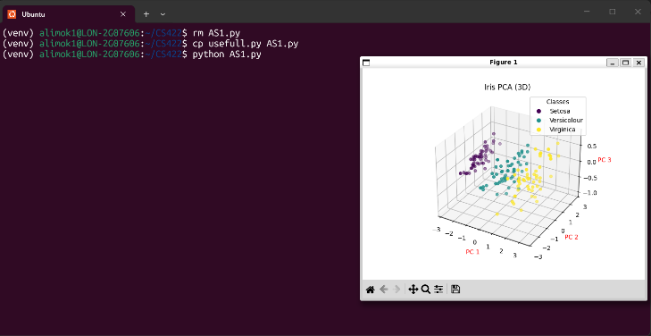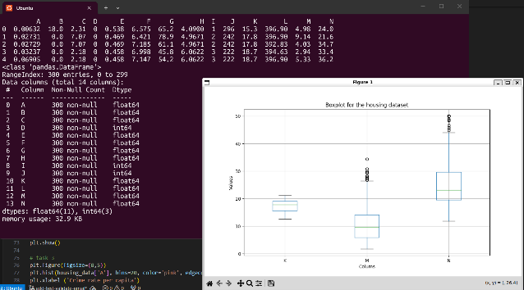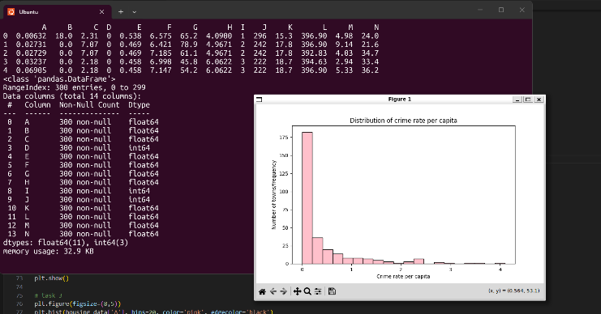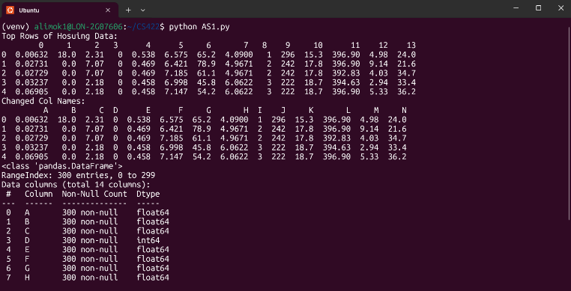

Screen Shots of Testing and Debuging
